FACULTY OF INFORMATION AND COMMUNICATION TECHNOLOGY

PROG 102 – PRINCIPLES OF SOFTWARE ENGINEERING

Title: Software Design for a Digital Public Good – Market Stall Allocation System
Due Date: Week 12
Lecturer/Examiner: Mr. Hassan Mansaray
Class: BBIT1202
Semester/Year: 2/1

NO | NAME | STUDENT ID | SIGNATURE
1 | ARSIEKEH MANSARAY | 905005947
2 | SARAN JANNEH | 905005796

Academic Honesty Policy Statement
I/We, hereby attest that contents of this attachment are my own work. Referenced works, articles, art, programs, papers or parts thereof are acknowledged at the end of this paper. This includes data excerpted from CD-ROMs, the Internet, other private networks, and other people's disk of the computer system.

Student's Signature: ___________________________ Date: ___________

LECTURER'S COMMENTS/GRADE: | For office use only upon receipt  Remark: _______________________  Date: _________ Time: _________  Receiver's Name: ________________

TABLE OF CONTENTS
- Introduction…………………………………………………………….…………3
- Project Overview………………………………………………………….………4
- Software Development Life Cycle (SDLC)............................................................5
- System Architecture Diagram…………………………………………………….7
- Prototype Development…………………………………………………………...10
- Projct Management………………………………………………………………..21
- License, Deign quality SDG Relevance…………………………………………...24
- GitHub Repository…………………………………………………………………26
- Conclusion…………………………………………………………………………27
- References…………………………………………………………………………28

1. Introduction
This report presents the complete software design documentation for the Market Stall Allocation System, developed as the Final Project for PROG102 – Principles of Software Engineering. The project required students to expand a previously designed Digital Public Good system into a fully documented software design, including a development methodology, complete system architecture, a functional prototype, and proper version control and open-source practices.
The Market Stall Allocation System is a web-based digital solution designed to address real challenges in market management across Sierra Leone, particularly in urban centres such as Freetown where market stall allocation is largely handled through manual, paper-based processes. The system aligns with SDG 8: Decent Work and Economic Growth, by promoting transparent, efficient, and accessible market management for traders and administrators alike.
This report documents all required project components: the Software Development Life Cycle model applied, the system architecture and component interactions, the Figma prototype screens, the project management plan including Gantt chart and Network Diagram, the software license selection, and the GitHub repository used for version control and collaboration.

2. Project Overview

2.1 Problem Statement
Market traders in Sierra Leone, particularly in Freetown's busy commercial areas such as Big Market, Lumley Market, and Congo Market, face a persistent challenge in the fair and transparent allocation of market stalls. Stall allocation is typically managed manually by market authorities using paper registers, which creates opportunities for favoritism, loss of records, difficulty in tracking active and expired allocations, and an overall lack of accountability.
Traders often have no formal way to register, view available stalls, or track their allocation history. Market administrators have no centralised system for managing registrations, payments, or generating reports. This system aims to bridge that gap through a structured, digital solution.

2.2 Proposed Solution
The Market Stall Allocation System is a web-based platform that enables market traders to register, view available stalls, and apply for stall allocations. Administrators can manage trader registrations, allocate stalls, track payment status, and generate usage reports. The system is built around the five core modules identified during requirements analysis: Trader Registration, Stall Management, Allocation Management, Payment Recording, and Report Generation.

3. Software Development Life Cycle (SDLC)

3.1 Chosen Model: Waterfall Model
The Waterfall Model was selected for the development of the Market Stall Allocation System. The Waterfall Model is a sequential, linear software development approach where each phase must be completed before the next begins. It was chosen for this project because the requirements of the system are clearly defined and well-understood from the outset, making a structured, phase-by-phase approach the most appropriate. The Waterfall model was selected for the development of the Market Stall Allocation System after careful consideration of alternative methodologies, particularly Agile. While Agile is well-suited for projects with evolving or unclear requirements, it relies on continuous client feedback across multiple iterations, which is difficult to manage within the fixed timeline and academic constraints of this project. In contrast, Waterfall's linear, phase-by-phase structure is a better fit here because the system requirements were clearly defined from the outset — the problem of manual stall allocation in Freetown markets is well understood, the target users are known, and the scope was fixed before development began. Additionally, the team operates with a structured submission deadline at Week 11, making iterative sprints impractical. Waterfall allowed the team to plan all deliverables upfront, assign responsibilities clearly, and progress through each phase — from requirements gathering to deployment — in a controlled and documented manner that aligns with the project's academic reporting requirements.

3.2 SDLC Phases Applied to This System
Phase 1: Requirement Analysis
During this phase, information was gathered from market authorities, traders, and administrators to understand the core needs of the system. Key requirements identified included trader registration, stall allocation and tracking, payment recording, report generation, and administrator access control. The output of this phase was a requirements specification document outlining all functional and non-functional requirements.
Phase 2: System Design
The system architecture was designed in this phase, including the database structure, user interface layouts, process flows, and component interactions. Design outputs included the system architecture diagram, database entity relationships, and interface wireframes (later refined into the Figma prototype).
Phase 3: Implementation
Developers write the system code based on the design documents. The key modules implemented include the Login system, Trader Registration module, Stall Allocation module, Payment Management module, and Report Generation module.
Phase 4: Testing
The system is tested to ensure all functions work correctly and securely. Testing activities include login testing, allocation workflow testing, payment recording testing, and report generation testing. The goal of this phase is to deliver a bug-free, stable system.
Phase 5: Deployment
The tested system is installed at the market management office and made available to users. Deployment activities include server configuration, database setup, staff training, and user documentation preparation.
Phase 6: Maintenance
After deployment, the system is continuously monitored and updated to fix errors, improve performance, and add new features as requirements evolve. Maintenance ensures the system remains relevant and functional over time.

4. System Architecture Design

4.1 Architecture Overview
The Market Stall Allocation System follows a layered web application architecture, where users access the system through a web browser, which communicates with the web application layer. The application layer is divided into four functional modules — Registration, Allocation, Payment, and Report Generation — all of which interact with a central database that stores all trader, stall, allocation, and payment records.

4.2 Architecture Diagram

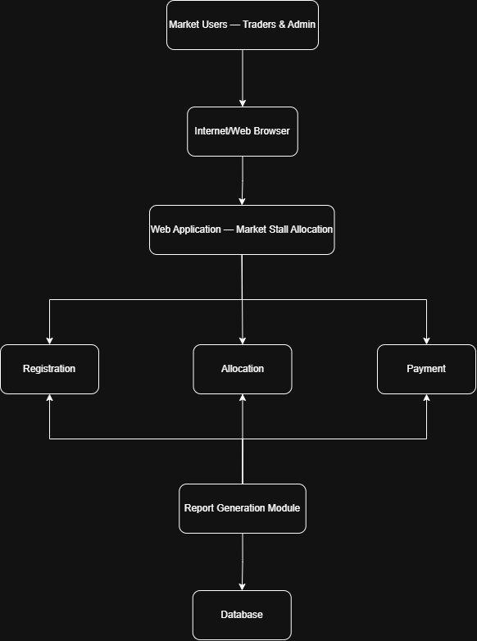
Figure 1: System Architecture Diagram — Market Stall Allocation System

4.3 Component Interaction
The following describes how the components of the system interact with one another:
- Market Users (Traders and Administrators) access the system through an Internet/Web Browser, submitting requests and receiving responses from the web application.
- The Web Application layer receives all user requests and routes them to the appropriate module — Registration, Allocation, or Payment — based on the action being performed.
- The Registration Module handles all new trader registration and profile management, storing trader data to the database.
- The Allocation Module manages the assignment of available stalls to registered traders, updating stall status and allocation records in the database.
- The Payment Module records and tracks all stall-related payments, linking payment records to specific traders and allocations.
- The Report Generation Module queries the database to compile and display management reports covering trader activity, stall occupancy rates, and revenue summaries.
- The Database serves as the central data store for all records across every module, ensuring data consistency and integrity throughout the system.

5. Prototype Development

5.1 Design Approach
The Figma design tool was used to create a high-fidelity prototype of the Market Stall Allocation System. The prototype was designed for a mobile interface using the iPhone 14 Pro Max frame size, with a consistent green-and-white color scheme reflecting the agricultural and market-based nature of the system. The design prioritizes simplicity and ease of use for traders and administrators with varying levels of digital literacy.
The prototype consists of ten screens covering the complete user journey from initial access to reporting. The design system applied throughout is as follows:
- Primary green: #1B5E20
- Bright green (active/success): #4CAF50
- Red (occupied/inactive): #F44336
- Light grey background and fields: #F5F5F5
- Border grey: #E0E0E0
- Placeholder text: #9E9E9E
- Font: Poppins/Inter

5.2 Prototype Screens
Screen 1: Splash/Welcome Screen


Screen 2: Login Screen

Screen 3: Register Screen

Screen 4: Dashboard
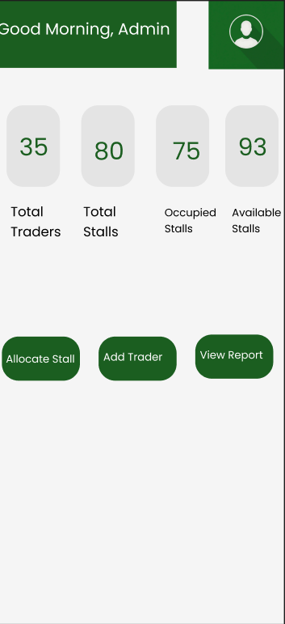
Screen 5: Trader List
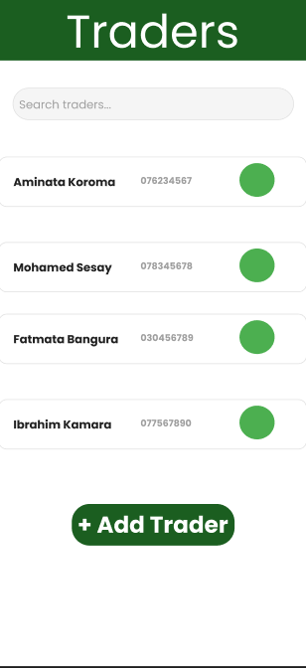
Screen 6: Stall List
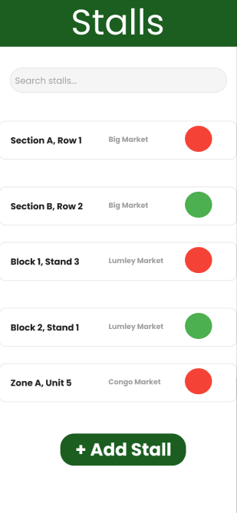
Screen 7: Stall Allocation
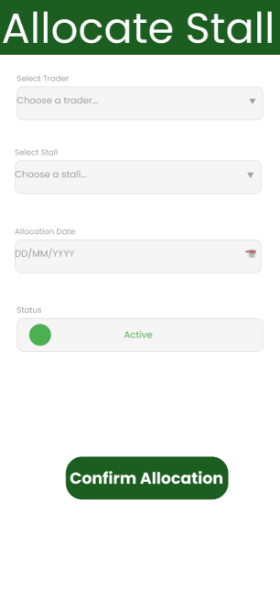
Screen 8: Allocation History
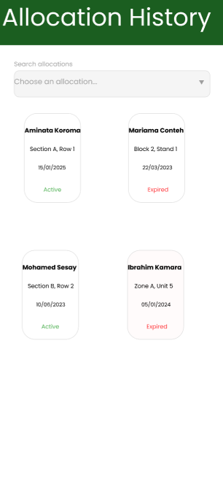
Screen 9: Report Screen
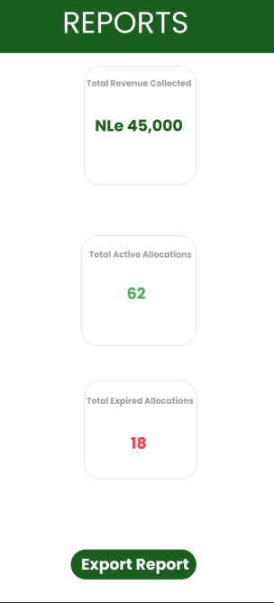
Screen 10: Profile/Settings
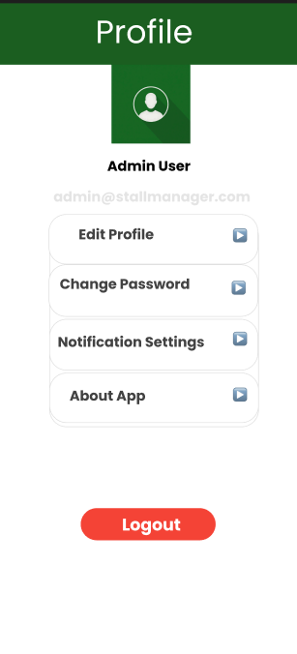

6. Project Management

6.1 Gantt Chart
The following Gantt chart outlines the planned development timeline for the Market Stall Allocation System, showing the duration and scheduling of each phase across six weeks:

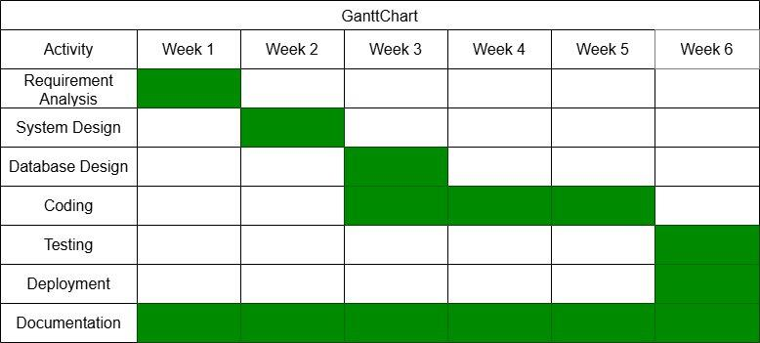
Figure 2: Project Gantt Chart showing development timeline across six weeks

6.2 Network Diagram
The Network Diagram illustrates the sequential dependency between all project activities, showing which tasks must be completed before the next phase can begin:
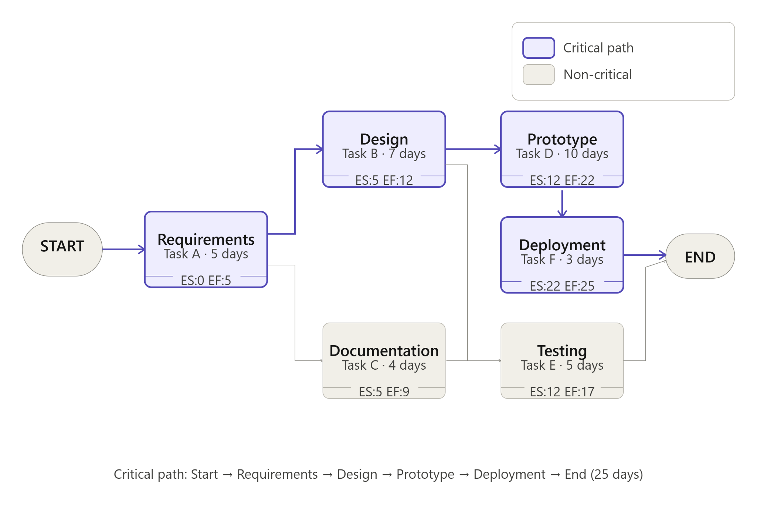
Figure 3: Network Diagram showing sequential task dependencies

6.3 Risk management
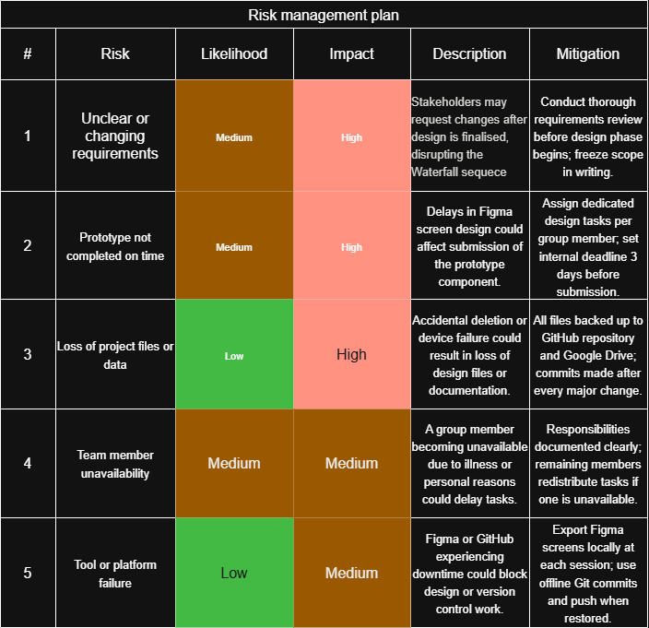

7. License, Design Quality and SDG Relevance

7.1 Software License
The Market Stall Allocation System is published under the MIT License. The MIT License was selected because it is one of the most widely adopted open-source licenses in the software industry. It permits any individual or organisation to freely use, copy, modify, and distribute the software, provided the original copyright notice and license text are retained in all copies or substantial portions of the software.
The MIT License was chosen specifically because it supports open-source development and collaboration, allowing other developers, market authorities, or NGOs working in Sierra Leone to adapt the system freely for their own contexts without legal restriction. It is simple to understand, places minimal restrictions on users, and is compatible with most other open-source licenses.

7.2 Design Quality (UI/UX)
The Figma prototype was designed following user interface best practices to ensure the system is clean, user-friendly, and visually consistent throughout. Key design decisions include a consistent green-and-white color palette reflecting trust and growth, rounded card components for a modern and approachable feel, clear visual status indicators using green and red dots to show stall availability at a glance, and large, clearly labeled action buttons to support users with low digital literacy. Navigation is intuitive and requires minimal learning time, making the system accessible to market traders and administrators alike.

7.3 SDG Relevance
The Market Stall Allocation System directly aligns with SDG 8: Decent Work and Economic Growth. SDG 8 calls for sustained, inclusive, and sustainable economic growth, full and productive employment, and decent work for all. The informal market sector is one of the primary economic activities for a significant portion of Sierra Leone's population, particularly in urban areas. By digitising the stall allocation process, this system promotes several of SDG 8's specific targets:
- Improving transparency and reducing corruption in stall allocation, giving all traders equal access to economic opportunities.
- Supporting the formalisation of the informal economy by creating digital records of trader registrations and allocations.
- Improving market revenue collection efficiency, which directly benefits local government and community services.
- Reducing administrative burden on market management staff, freeing time for other value-adding activities.

8. GitHub Repository
The complete project documentation, including all design files, diagrams, and report documents, was published to a public GitHub repository as required. The repository is structured with a docs folder containing the architecture diagram, Gantt chart, and project report, and is published under an MIT License with a README.md file describing the project.
Repository URL: https://github.com/successor006-png/PROG102_FinalProject

9. Conclusion
The Market Stall Allocation System represents a well-structured digital solution to a real and pressing challenge in Sierra Leone's informal market sector. Through the application of the Waterfall SDLC model, a clearly designed system architecture with five core modules, and a clean, user-friendly Figma prototype consisting of ten screens, this project has demonstrated the full cycle of software design from requirements analysis through to deployment planning.
The system's alignment with SDG 8 reinforces its relevance beyond academic exercise — it is a practical tool that, if implemented, could improve the transparency, efficiency, and fairness of market stall management in Sierra Leone's urban markets. The MIT License applied to the repository ensures that the design remains open and adaptable for any organisation that wishes to build upon it.

References
Sommerville, I. (2016). Software Engineering (10th ed.). Pearson.
Pressman, R. S., & Maxim, B. R. (2014). Software Engineering: A Practitioner's Approach (8th ed.). McGraw-Hill.
United Nations. (2015). Sustainable Development Goals: SDG 8 – Decent Work and Economic Growth. https://sdgs.un.org/goals/goal8
PROG102 – Principles of Software Engineering Lecture Notes, Limkokwing University of Creative Technology, Sierra Leone, 2026.

